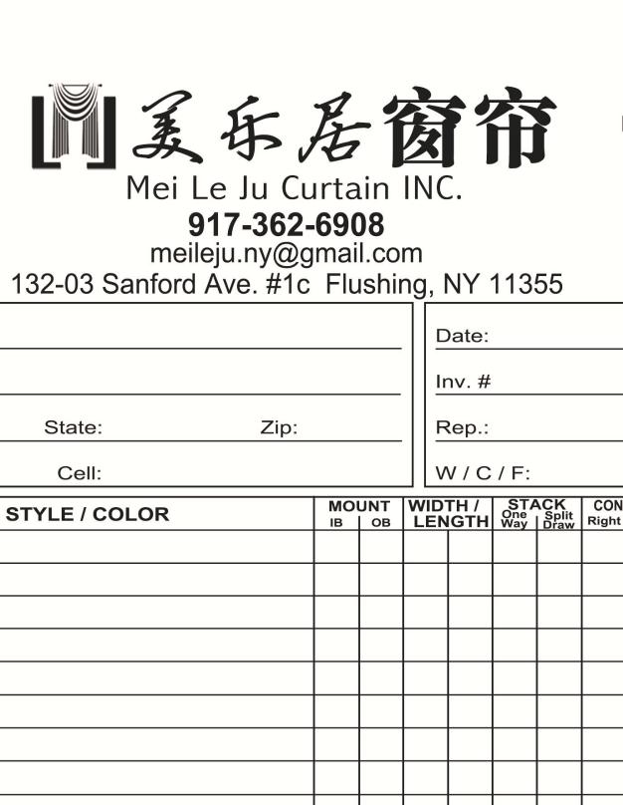

*Date: / /*

Measurement Sheet

**Location**

Floor:

Front Back

Left Right

**Customer Info**

Name:

Address:

Telephone:

**Curtain Info Amount :**

**Width: 7 inch**

**Mounding**

**High: 3 inch wood + 1 inch track**

**Curtain Rod or Track**

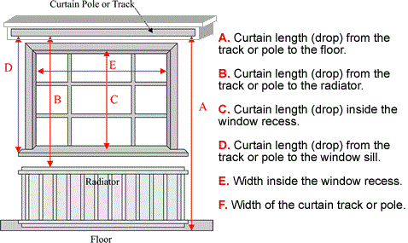

1. Curtain length (drop) form the track or rod to the floor.
2. Curtain length (drop) from the track or rod to the radiator.
3. Curtain length (drop) inside the window recess.
4. Curtain length (drop) from the track or rod to the window sill.
5. Width inside the window recess.
6. Width of the curtain track or rod

D

B

A

C

E

F

|  |  |  |  |
| --- | --- | --- | --- |
| A |  | D |  |
| B |  | E |  |
| C |  | F |  |

**Finished Product**

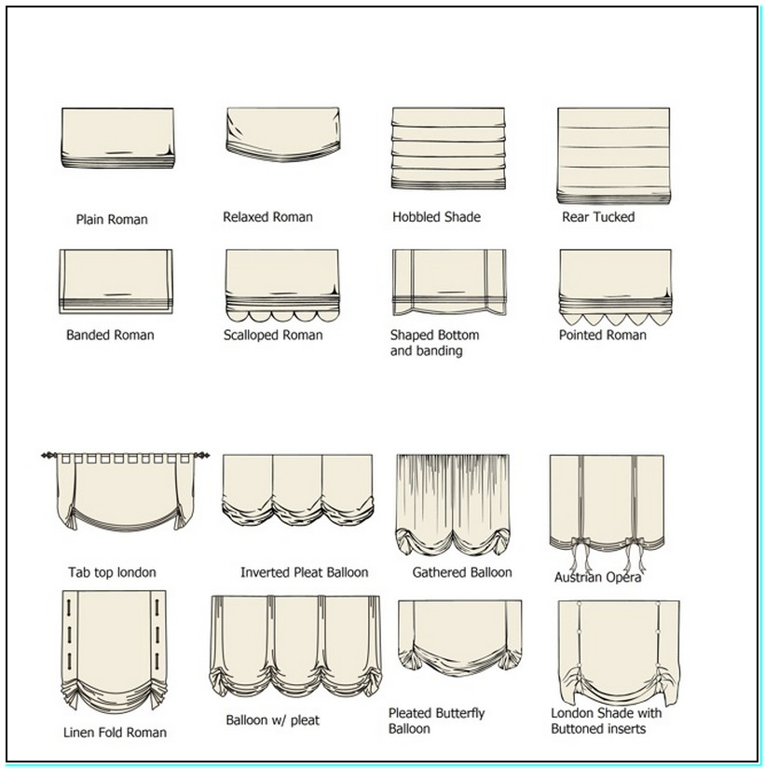

**Curtain:**

Width: Length:

**Valance** Yes No

* I confirm that all the measurement listed above is correct.

Customer Signature: Date: / /